Product name :- sugar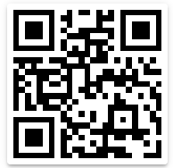

Cost :- 30

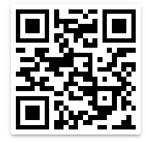

Product name :- bread

Cost :- 20

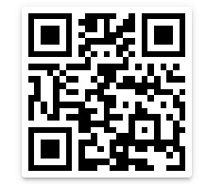

Product name :- Milk

Cost :- 50

This is OCR Reader Feature.

Name of Application is blind helper